**Defect #1**

**Severity**: Low

**Priority**: Medium

**Status**: New

**Environment**:

**Build**:

**Description**: There is no flyout when hovering over Kontakt

**Other Aspects**: Kontakt feature being very important from business point of view and to have consistency with other option like Bausparen, Rechner etc. , it should also have flyout on hovering over. User may expect flyout like other options have.

**Steps to reproduce:**

1. Launch <https://www.bausparen.at/de/bausparen.html>
2. Hover over Kontakt

**Expected Result**: Flyout with contact or any minimal details

**Actual Result**: No flyout

**Resolution suggestion**: Have flyout with minimal contact details

**Evidences**:

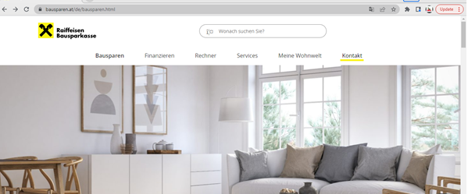

**Defect #2**

**Severity**: Low

**Priority**: Low

**Description**: Search box is triggering search without any search criteria and initiating search for empty string

**Other Aspects**: This is more of a usability issue, User might mistakenly type Enter into Search box and unnecessarily land it into next page

**Steps to reproduce**

1. Launch <https://www.bausparen.at/de/bausparen.html>
2. Click on Search box and type Enter

**Expected Result**: Search box should not initiate search with empty criteria

**Actual Result**: Search box initiating search with empty criteria and navigating to next page

**Resolution suggestion**: Keep a validation on the search box and display a warning when triggering search with empty input

**Evidences**:

Clicking on Search box

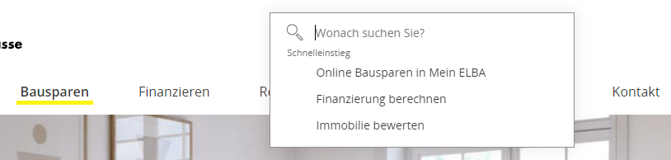

After typing Enter navigating to next page

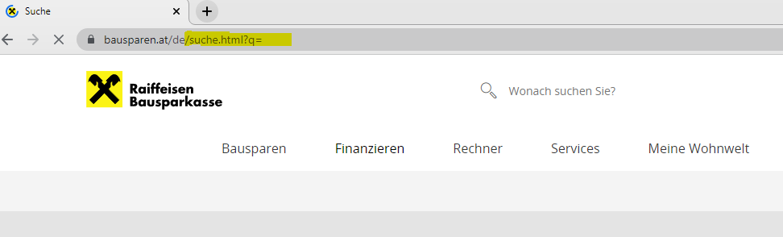

**Defect #3**

Severity: Cosmetic/Good to have

**Priority**: Low

**Description**: Not able to type in Search box when clicked on lens icon

**Other Aspects**: On clicking at lens icon in Search box, we are not able to type and the cursor gives false impression as in we are in the input text field

**Steps to reproduce**

1. Launch <https://www.bausparen.at/de/bausparen.html>
2. Click on lens icon on Search box on top of the page
3. Start typing search criteria

**Expected Result:** Search box should allow entering text on lens icon

**Actual Result:** Search box is not allowing entering text on lens icon

**Resolution suggestion**: Allow entering text in complete search box

**Evidences:**



**Defect #4**

**Severity**: Low

**Priority**: Low

**Description**: Phone, message, email and Feedback icons are not actionable

**Other Aspects**: The icons changes color on hovering over gives the feeling that they can be clicked and action upon but they are not

**Steps to reproduce**

1. Launch <https://www.bausparen.at/de/bausparen.html>
2. Scroll to bottom of page
3. Hover over Phone, Message, email and feedback icons and click

**Expected Result**: Click on icon should navigate to respective page

**Actual Result**: Icon is not clickable

**Resolution suggestion**: Make them actionable or remove the color changing of icon

**Evidences**:

